Results for p as a response variable, and 16 predictor variable(s).

n: 65535 r: 0.894 r²: 0.799 r²adj: 0.799 F: 16240.968 P: 0

Akaike's Information Criterion (AICc): -125278.216

Variable Coeff. Std Coeff. VIF Std Error t P Value

Constant 1.725 0 0 0.015 113.512 0

bio_15 0.001 0.06 6.587 <.001 13.421 <.001

bio_19 -0.006 -0.353 5.343 <.001 -87.226 0

bio_3 -0.006 -0.085 3.303 <.001 -26.761 <.001

bio_4 <.001 -0.993 4.888 <.001 -256.306 0

CST <.001 0.002 1.104 <.001 1.331 0.183

HII 0.009 0.237 1.815 <.001 100.301 0

LUCC <.001 -0.045 1.203 <.001 -23.454 <.001

PC -21.047 -0.036 1.006 1.016 -20.711 <.001

s01 0.249 0.034 1.775 0.017 14.546 <.001

s02 -0.561 -0.077 1.553 0.016 -35.231 <.001

s03 0.491 0.067 1.92 0.018 27.741 <.001

s04 -0.723 -0.107 1.32 0.014 -53.074 0

s05 -0.891 -0.122 1.24 0.014 -62.458 0

s06 1.44 0.203 1.141 0.013 108.219 0

s07 -0.262 -0.037 1.119 0.013 -19.996 <.001

s08 0.234 0.033 1.306 0.014 16.588 <.001

Condition Number: 6.082

Mean of Correlation Matrix: 0.126

1st Eigenvalue divided by m: 0.19

Descriptive Statistics:

p Estimated Residuals

Min 0.003 -0.272 -0.377

Max 0.752 0.708 0.389

Mean 0.22 0.22 <.001

Std.Dev. 0.207 0.185 0.093

Skewness 0.274 0.075 0.106

Kurtosis-495545347.217 -495545236.098 -495552912.498

Partial Regression Results:

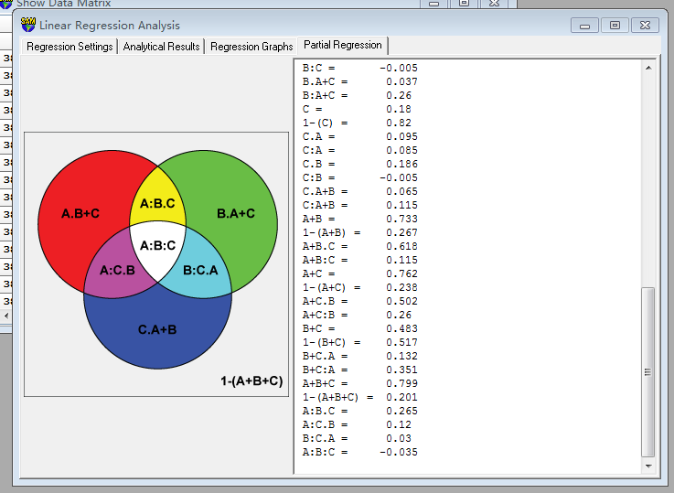

Predictor set {A}:

bio_15

bio_19

bio_3

bio_4

Predictor set {B}:

CST

HII

LUCC

PC

Predictor set {C}:

s01

s02

s03

s04

s05

s06

s07

s08

A = 0.666

1-(A) = 0.334

A.B = 0.436

A:B = 0.23

A.C = 0.581

A:C = 0.085

A.B+C = 0.316 a

A:B+C = 0.351

B = 0.297

1-(B) = 0.703

B.A = 0.067

B:A = 0.23

B.C = 0.303

B:C = -0.005

B.A+C = 0.037 b

B:A+C = 0.26

C = 0.18

1-(C) = 0.82

C.A = 0.095

C:A = 0.085

C.B = 0.186

C:B = -0.005

C.A+B = 0.065 c

C:A+B = 0.115

A+B = 0.733

1-(A+B) = 0.267

A+B.C = 0.618

A+B:C = 0.115

A+C = 0.762

1-(A+C) = 0.238

A+C.B = 0.502

A+C:B = 0.26

B+C = 0.483

1-(B+C) = 0.517

B+C.A = 0.132

B+C:A = 0.351

A+B+C = 0.799

1-(A+B+C) = 0.201

A:B.C = 0.265 d

A:C.B = 0.12 e

B:C.A = 0.03 f

A:B:C = -0.035 g